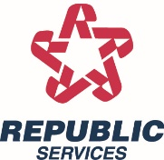
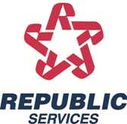

CITY OF NEW BLOOMFIELD

RESIDENTIAL BULK SPRING CLEAN-UP

WHEN: April 24, 2024

Spring Bulk Clean-Up is for RESIDENTIAL customers only!!

All customers must be located inside the city limits and abide by the following guidelines:

CLEAN-UP GUIDELINES

All items must be set at the curb by 5:00 a.m.
All items need to be bagged or bundled so 1 person can easily handle them.
All lumber, guttering and other items of length must be tied in bundles and cut in 4 foot lengths so 1 person can easily handle the materials.
All items that fit in a cart need to be in cart with regular service
NO HAZARDOUS WASTE of any kind.
NO LIQUID WASTE of any type such as paints, pesticides, oil, etc.
NO YARD WASTE such as brush, limbs, grass or leaves.
NO CAR PARTS such as tires, motor oil, batteries, etc.
NO WHITE GOODS (refrigerators, stoves, hot water heaters, washing machines or dryers)
NO CONCRETE or large solid items that could damage our equipment.

ANY ITEMS IN QUESTION WILL BE LEFT BY THE REPUBLIC SERVICES DRIVER.

IF YOU HAVE ANY QUESTIONS CONCERNING THESE GUIDELINES, PLEASE CONTACT OUR OFFICE AT (573) 635-8805.

